**Instructions to execute:**

1. Download executable jar from GitHub using following URL.

<https://github.com/priyap23/AccessPointApplication/blob/master/target/ApplicationB.jar>

<https://github.com/priyap23/AccessPointApplication/blob/master/target/ApplicationA.jar>

1. Run executable jar:
   1. Open command prompt.
   2. Go to the directory where executable jar is located.
   3. Hit below command.

java -jar ApplicationB.jar port

java -jar ApplicationA.jar directorypath filename hostname port

Note: Please note that first execute the ApplicationB.jar as it is server and then execute ApplicationA.jar file. Port for the both the application should be same because ApplicationA send message to ApplicationB.

For example :

java -jar ApplicationB.jar 5000

java -jar ApplicationA.jar E:\MyData\Resume AP.json localhost 5000

* 1. Ensure the application is up without error as shown in below image.

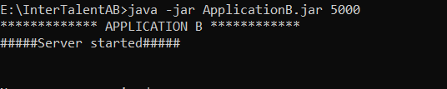

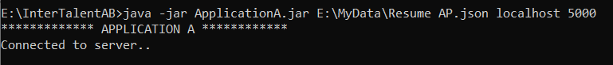

* 1. Application reads the json file which is in below format.

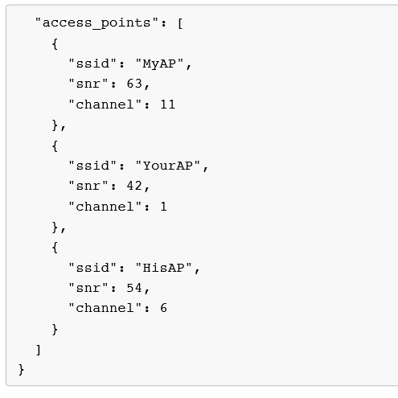

* 1. Modify the input file and save it. Go to ApplicationB window, find message as below.

